Kentucky Health Data

Entering Student Health Data for Inclusion in

End-of-Year Health Reports

Kentucky Department of Education

Division of District Support

School Year 2019-2020



KDE Contacts:

Angie McDonald, RN, Education School Nurse Consultant

angela.mcdonald[@education.ky.gov](mailto:angela.mcdonald@education.ky.gov)

Division of District Support

502-564-5279 ext. 4430

Samantha Engstrom, Resource Analyst II

[samantha.engstrom@education.ky.gov](mailto:samantha.engstrom@education.ky.gov)

Division of District Support

502-564-5279 ext. 4434

# Health Data Entry

**Overview**

The Health folder of Student Information allows a user to record health information about individual students. It is important the health information recorded is done accurately and in the correct fields.

**Health Conditions**

*Path: Student Information>Health> Conditions Tab*

Data on all students with a documented chronic disease must be entered under the appropriate health condition code. Students with a chronic disease may also experience chronic absences. Schools need to be aware of all students with a chronic health condition to better serve the student and reduce any barrier to learning. The chronic health condition may be found on the student health information card that the parent or guardian has completed and/or documentation from the student’s medical provider.

KRS 156.502 describes health services to be the provision of direct health care including the administration of medication, the operation, maintenance, or health care through the use of medical equipment or the administration of clinical procedures. Chronic health conditions that require daily delivery of a health service (by either the school nurse or trained unlicensed school personnel) during the instructional day should be entered in the health tab under health condition and a brief description of what the required service written in the comments box.

Example: If a parent of a student with ADHD requests that the student receive a prescribed medication during the day (such as Ritalin or Adderall) the reason for the medication is the *Health Condition*. Using the steps on page 4 enter the following information.

* Search for ADHD
* Locate the health condition from the drop down box.
* Double-click on ADHD. The description and ICD-10 Code will be auto-populated.
* Under comments, enter the health service that is authorized for the school to perform (Example: administer Ritalin every day at noon).
* Enter the dosage as written on the prescription label.

Some students will not require a daily scheduled medication or medical procedure but may require accommodations for a chronic health condition. For example, students with an overactive bladder may need accommodations for more frequent bathroom breaks. If urinary frequency or incontinence of bowel or bladder is noted on the student’s health card, the health condition can be found from the drop down menu or by typing in the first few letters of the chronic health conditions, then select the most appropriate ICD-10 code and then in the comment section, include a comment stating the student needs frequent bathroom breaks. Students requiring procedures such as tracheotomy care, tube feeding, or catherization should also be entered with a description of the health service required to be provided.

In addition, any chronic health condition that does not require a daily scheduled action; but potentially could require an emergency action/medication (if the emergency situation occurred) should also be entered on the Health Conditions tab and also a check placed in the “display flag” box. picture of health conditions flag

Examples include:

1. The student is known to have asthma but doesn’t bring the inhaler to school. Asthma should be entered as the chronic health condition and then in the user warning box states that the child has no inhaler at school. Or, if the student has asthma and brings inhaler to school, enter the information how often the inhaler is to be used and/or where the inhaler is located.
2. Some students may require medication prior to an activity such as physical exercise. The user warning flag may also alert teachers and/or staff of the health services needed prior to the activity.

Teachers and staff will be able to see information included in the user warning box when the arrow is hovering over the medical condition display flag.

Please use the display flag phto of health conditions flag
 and user warning box for chronic health conditions to provide information on how to provide emergency care for the student. Health Condition EOY Summary Report will only pull data from this flag.

You may continue to use the General Campus Medical flag picture of medical display flag for ONLY non-health services information to notify teachers, such as “wears glasses.”

**Use the Description Search to locate the Health Condition/ICD-10 Code picture of search icon**

Choose from the drop down menu the Health Condition for student.

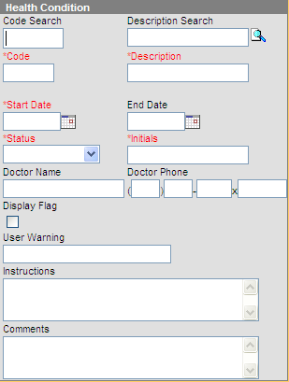

**Steps to Enter a Health Condition:**

1. Select New Condition at the top of the Conditions tab.
2. Enter the name of the condition in the Condition Search box, such as ADHD or diabetes.

Click the magnifying glass icon to search the ICD-10 entries.

1. Entries that match will show up in blue. Select the correct entry to load the name of the condition, as well as its code.

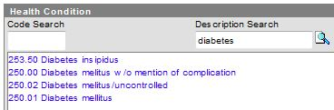

1. Enter the Start Date.
2. When or if the condition is resolved, an End Date should be used to indicate the condition is no longer being tracked or has been resolved. Enter the status of the condition, Not Resolved, Resolved or Unknown.

*NOTE: If an end date is entered for this school year and the student returns the following school year with the same health condition, this information will have to be re-entered.*

1. The person entering this information should put their initials in the Initials field.
2. The name of the doctor who diagnosed the condition may be entered in the Doctor Name field. This information is used in conjunction with Medicaid billing for services.
3. Enter the Doctor’s Phone Number, if available.
4. Select the Display Flag checkbox IF this condition requires a warning about an EMERGENCY action that would need to take place if it occurred (e.g. Diastat gel administered for a seizure or Glucagon for diabetic episode). Selecting this will result in a flag appearing next to the student’s name. The start and end dates determine when the flag will be displayed.
5. 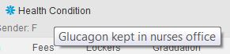Enter a User Warning comment that will appear when the flag is hovered over. This is required if the Display Flag checkbox is selected.
6. Enter any instructions for the condition in the Instructions field.
7. In the Comments box, enter in additional information such as instructions from medical provider.
8. Click Save Condition at the top of the tab.

# Immunizations

*Path: Student Information > Health > Immunizations**Tab*

The immunizations tab includes fields for storing data related to the student’s immunization certificate. The IC Health module provides reports that identify students with expired certificates, missing certificates as well as type of certificate. **Required data entry includes certificate date, expiration date and certificate type**. These will be reported to the Kentucky Department of Education at the end of the school year.

*Required for Initial Entry and 6th Grade Students*

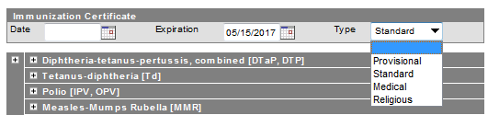

**Steps to enter a student’s Kentucky Immunization Certificate data:**

1. Enter the date the certificate was generated in the provider’s office in the first date box.
2. Enter the expiration date (found above the signature) of the certificate submitted. If religious exemption is checked, no expiration date is required.
3. Select the type of certificate. If Medical Type is chosen, user should specify the Medical waiver under the immunization that is applicable.

**Entering Immunization Waivers**

To enter immunization waivers, open the correct shot record, select the district approved waiver reason, and enter the date in the MM/DD/YYYY or MMDDYY format. When you click Save at the top of the tab, it will refresh the Summary.

# Health Screenings

*Path: Student Information >Health > Screenings Tab*

The Health Screenings tab allows you to store health screening information on a student. If a screening has been completed in the past, it will be shown on the Screening History. To edit a previous screening, simply click the blue link/bar.

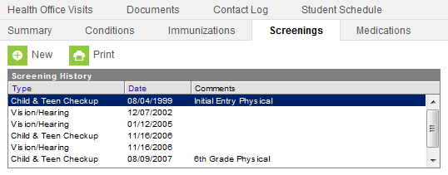

**Steps to entering a New Screening**

1. Click New at the top of the Screenings tab.
2. The date will auto populate with today’s date. If this is not correct, then enter the correct date by typing it in with the MM/DD/YYYY or MMDYY format or by clicking on the date box, and selecting the correct day.
3. From the Type dropdown box, select the required screening. This will open the correct screening records for this type.

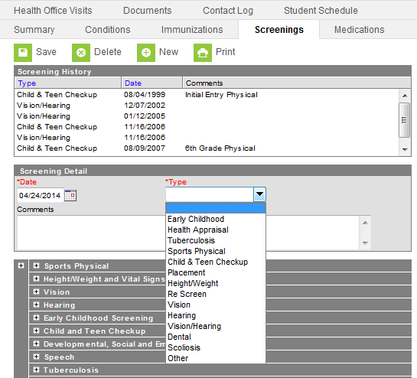

1. Enter in the pertinent informationrelated to the student’s screening in the appropriate boxes.
2. When you have completed the screening information, click Save at the top of the tab. This record will now appear with the Type, Date, and Comments visible in the Screening History window.

**Batch Health Screening Entry**

*Path: Health >Batch Health Screening*

The Batch Health Screening tool allows for mass entry of screening results for a group of students.

**Steps to Batch Entry Screenings:**

1. Select the school and year on the gray Campus Toolbar.
2. Select the Batch Health Screening tool from the Health Module.
3. Types of screenings (vision and hearing) may be entered using the batch tool.
4. To enter a batch screening, first select the grade level for the students.
5. If all students in the grade level will have the same screening type and results status, select All. If particular students will have a particular type/status combination, select those students using the Shift or Control keys while clicking the mouse.
6. Select the relevant screening type and test type. (Note: Type must be selected to count on the Kentucky Health Screening Report)
7. Select the relevant status for those students.
8. Click Submit.

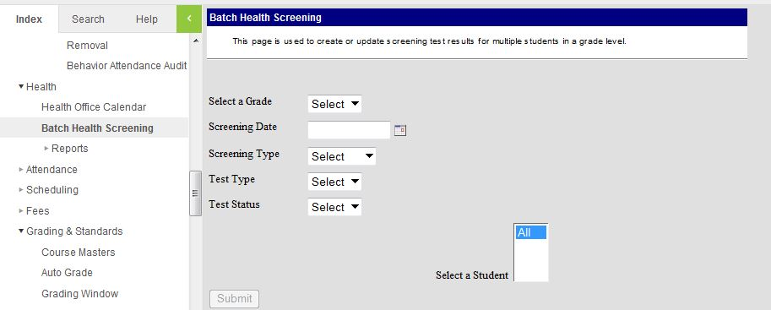

The screenings will then be written on the student’s health screening tab and will be included in the screening compliance report.

# Health Screenings Guidelines

**Physical Exams (Required) - Grades 00 and 06**

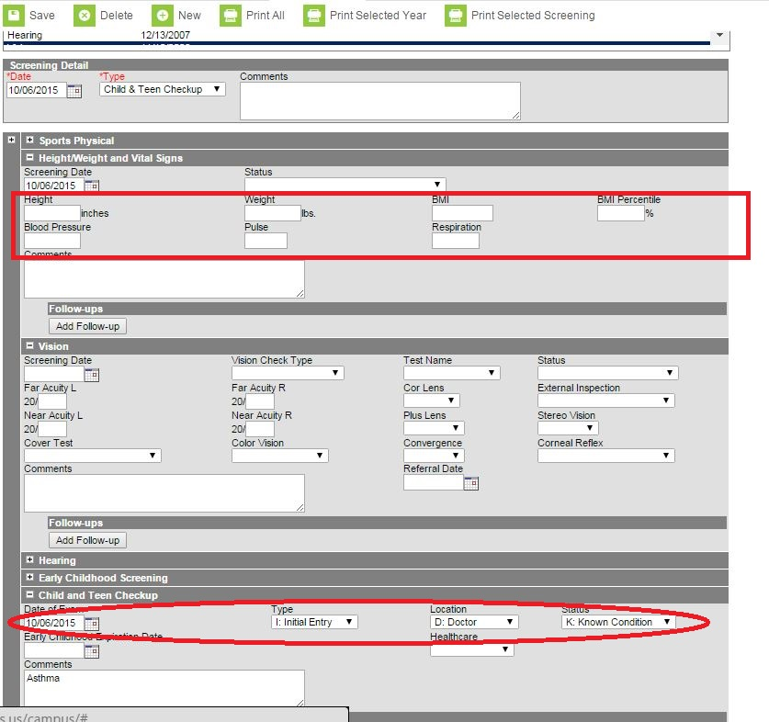

Requirements:

* For initial entry into Kindergarten, if the student has previously received an Initial Entry Health Exam for entrance into either Head Start or Preschool, the Initial Entry Exam meets the preventative health exam requirement for initial entrance into a Kentucky public school.
* For entry into 6th grade, the student shall have a “Child & Teen Checkup” within one year of entering 6th grade.
* Date of Physical must be entered in this field.

702 KAR 1:160 allows school district the option of extending compliance with the physical exam requirement (initial entry and 6th grade) not to extend more than 2 months from the first day of school. **Therefore,** **Infinite Campus will count the student as meeting this requirement up until October 15 of the current school year**.

(Example: For a student entering grade 6 in a school that begins August 1, 2018, the physical exam must occur between August 1, 2017 and October 15, 2018**.**

# Vision Screening - School determines which grades will be screened

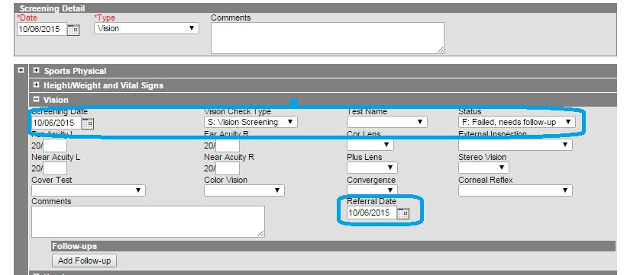

**Vision Screenings**

The vision test type is “S” = Vision Screening and the date should be between the first day of school and the last day of school.

* Enter Date of Screening, Status (P: Pass/F: Fail)
* Test Type (S: Vision Screening)

**Vision Referrals**

The referral date is between the first day of school and the last day of the current school year.

* If failed original vision screening enter Referral Date, Status (F: Fail) and Test Type (R: Referral)

**Vision Exams (Required) - Grade 00**

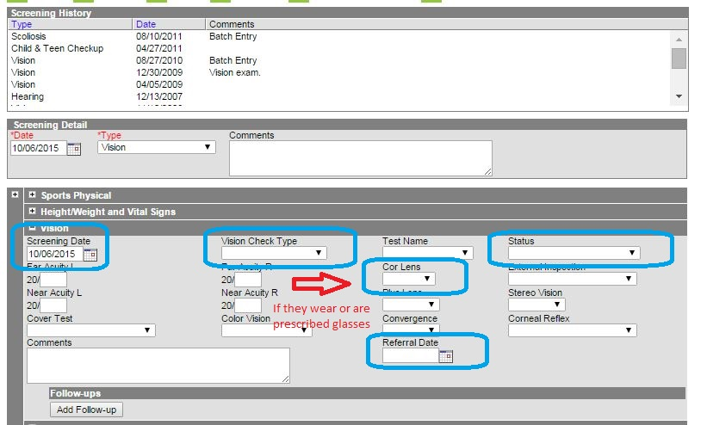

**Vision Exams**

The vision test type is “E: Vision Exam”. The exam must be completed no later than January 1st of the first year a 3, 4, 5 or 6-year-old enrolls in a Kentucky public school. Only one (1) vision exam is required.

Enter Date of Exam, Status (P: Pass/F: Fail)

* Test Type (E: Vision Exam)

# Hearing Screenings - School determines which grades will be screened

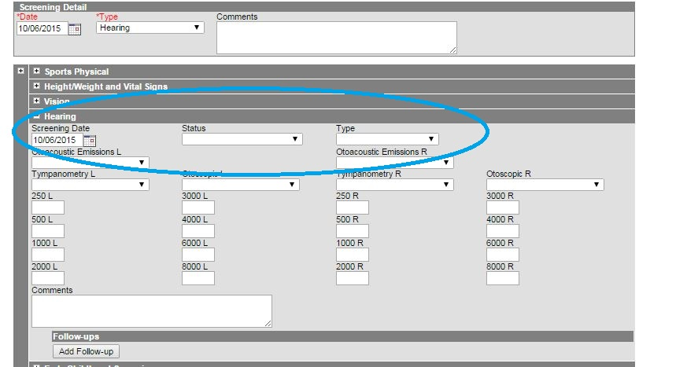

**Hearing Screenings**

The hearing type is “O” = Original or “OE” = Outside Exam and the date must be between the first day of school and the last day of the current school year.

* Enter Date of Screening, Status (pass/fail), Test Type (select appropriate type)

**Hearing Referrals**

* Enter Date of Referral, Failed for status and “R” for Test Type

# Dental Exam or Dental Screenings (Required) - Students Aged 5 or 6

Districts are required to enter a dental exam or dental screenings for students aged five (5) or six (6) who enroll in a public school. Students are required to show proof of a dental screening or dental exam no later than January 1 of the first year of enrollment in Kentucky.

* Enter the Date of the screening/exam.
* Select the Test Type from the dropdown list, either Screening or Exam.
* If referral needed, enter the date a referral was made.
* Click Save.

**\***The student may be four (4) years of age when the exam or screening occurs, as long as the child’s fifth (5th) birthday is no later than December 31 of the same calendar year and this is the first year the child is enrolled in Kindergarten.

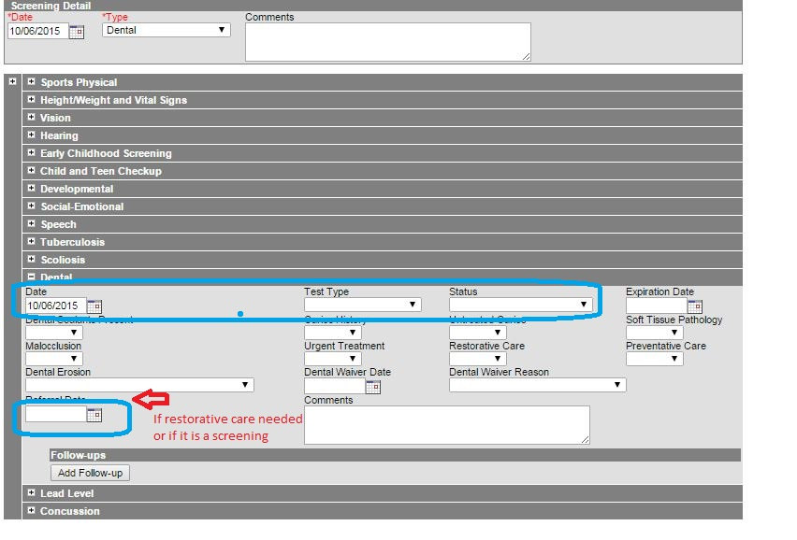

# Health Data Verification Instructions

The Health Conditions & Alerts Summary and Student Immunization and Screening information will be extracted by KDE (no district submission required). Data should be cleaned up and ready for extraction by June 1st.

**End of Year Health Objective:**

To verify district health data for 2018-19 school year, the data should be verified by reviewing the following Infinite Campus extracts for accuracy prior to June 1st

**Health Condition Summary**

*Path: Health>Reports>Health Condition Summary*

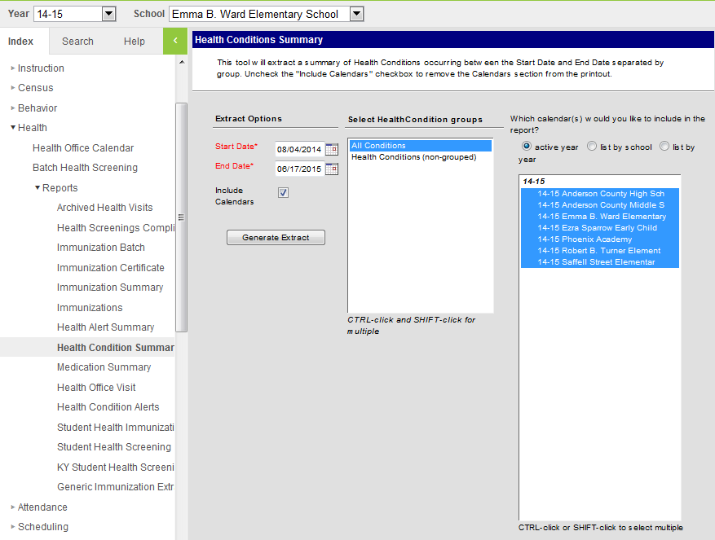

1. Enter the Start and End Dates for the report. (Beginning of fiscal year through June 30th for state reporting)
2. Select All Conditions
3. Select all calendars for state reporting purposes. To select all calendars, use Ctrl-click or Shift-click.
4. Select Generate Extract
5. Review and confirm the data generated by the report prior to June 1st.

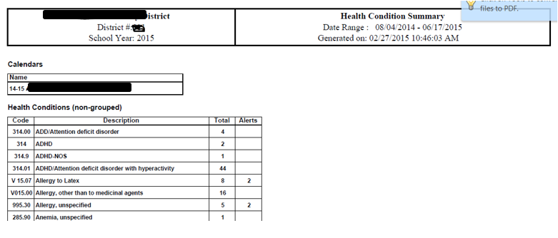

# Immunization Certificate

*Path: Health>Reports> ImmunizationCertificate*

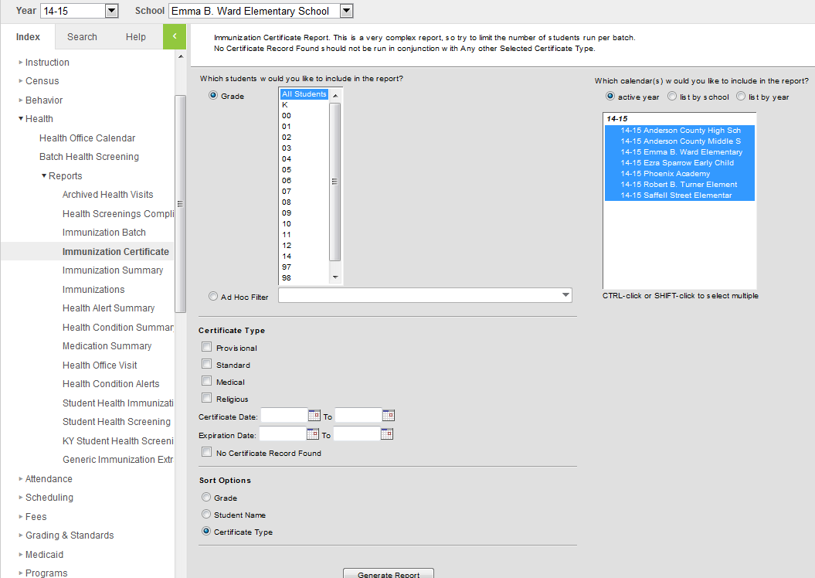

CTRL-click grades 00 and 06

1. Highlight all schools with grades 00 and 06
2. Click the “No Certificate Record Found”
3. The report will list all grade 00 and 06 students who do not have a current valid certificate.
4. Work with parents/guardians to get a valid certificate.
5. Review and confirm the data generated by the report prior to June 1st.

# Sample Immunization Certificate ReportStudent Health Screening

*Path: Health>Reports>Student Health Screening*

screenshot of KY Student Health Screening Report


1. Generate Report

Review and confirm the data generated by the report prior to June 1st

# Appendix A

**Overview of School Health Requirements per 702 KAR 1:160**

| **Type** | **Age of child** | **School Documentation** | **Data Entry into IC?** |
| --- | --- | --- | --- |
| Physical exam | 3,4, or 5 | Initial entry to school (can accept Head Start or Preschool) | Yes |
| Physical exam | 10, 11 or 12 (usually) | Performed up to 1 year prior to 6th grade entry. Student repeating grade 6 are exempt from exam | Yes |
| Vision exam | 3,4,5 or 6 | Initial entry to school (can accept Head Start or Preschool) | Yes |
| Dental exam/screening | 5 or 6**\*** | Entry to grade 00- ONLY | Yes |
| Hearing and vision screening | any age | School determine which grades screened | Yes |
| Immunizations | varies | Immunization certificate for Grades 00 and 6th  Immunization certificate reviews for  DPH annual immunization survey for  Grades 00, 7th, 11th (and 12th for 2018-  2019 school year only) | Yes |
| Medication administration | varies | Medication administration for scheduled, PRN & ER | preferred |
| Health office visits | varies | Individual health office visits and treatments | preferred |

* Dental Exam/screening must be between Jan 1 and December 31 of year enrolled in Grade 00.

FYI- a child may be 4 years old at time of dental exam or screening, but must be at least 5 years old

by Dec 31 of year enrolled in Grade 00

# Appendix B

**System Administration**

*System Administration>Preferences>System Preferences*

Sometimes a chronic health condition is not set up in the system to be “flagged” Before any health condition may be “flagged”, there is some set-up that needs to be done under System Administration>Preferences>System Preferences and System Administration>Health>Conditions List.

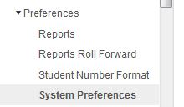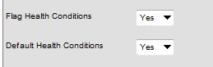

The preference for Flag Health Conditions and Default Health Conditions should both be set to ‘**Yes**’.

Please use the display flag photo of health condition alert symbol and user warning box for chronic health conditions to provide information on how to provide emergency care for the student.

**Instructions on flagging a health condition**

*Path: System Administration > Health > Condition List*

Once you have verified that these system preferences have been selected, you will need to designate the health conditions you want to be able to flag with a user warning.

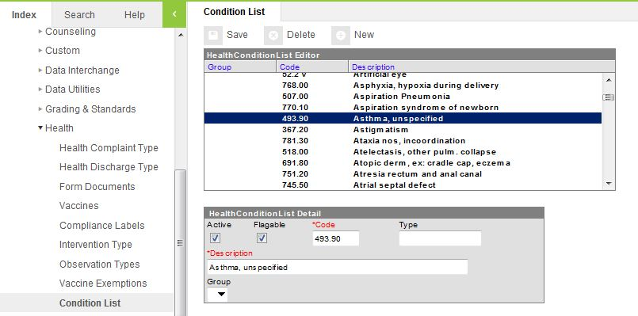

**Steps to Flagging Condition:**

1. Select the condition you want to flag by clicking on the condition name in the Health Condition List Editor.
2. Mark the flagable checkbox. This allows a user to add a health condition flag to any student with that particular health condition, if needed.
3. Click Save.

**Note:** This will need to be done for each health condition that might need an alert flag.

# Appendix C

**Health Screenings Ad Hoc reports**

*Path: Ad Hoc Reporting >Data Export > State Published*

The following ad hoc reports are useful for checking Health Screenings in Infinite Campus. If you do not have access to these reports contact your district administrator for Infinite Campus and have them copied into one of your user groups.

student HEALTH Audit Grade 00 with no Physical Exam



student HEALTH Audit Grade 00 with no Vision Exam

filter  icon student HEALTH Audit Grade 06 w/no Physical Exam

You can use the ad hoc filters to search for students by double clicking on the name of the filter in the saved filter list or by clicking it to highlight it and clicking the search button.

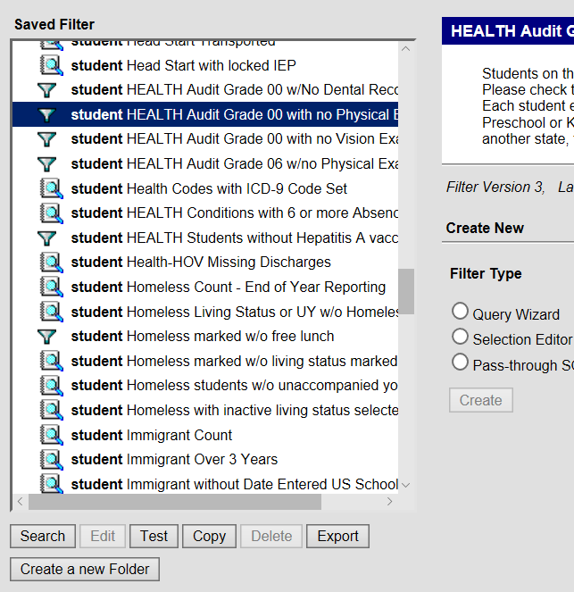

Student’s whose records need to be reviewed will be listed to the left of the screen. Click on the student’s name and go to the screenings tab.

*Path: Student Information >Health > General > Screenings tab*

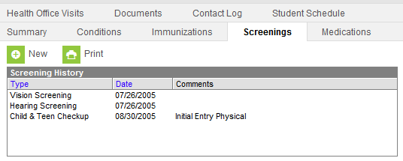

**Grade 00 with no Physical Exam**

Students on this report did not meet the criteria of an exam dated before October 15 and entered into IC. Please check to see if the date is incorrect or if there is evidence that they did have an exam prior to 10/15. Each student enrolled in a KY public school must show evidence of an initial entry exam (Head Start, Preschool or Kindergarten) prior to October 15 of the current school year. Students who enroll from out of state are allowed 2 months extension.



**Grade 06 with no Physical Exam**

Students on this report did not meet the criteria of an exam dated between a year prior to the start of school and October 15 and entered into IC. Please check to see if the date is incorrect or if there is evidence that they did have an exam during this period. Each student enrolled in a KY public school Grade 6 must show evidence of a physical exam within one year prior to entering 6th grade or no later than October 15 of the current school year. Students who enroll from out of state are allowed 2 months extension.

The query will pull students who have no exam or have one outside the valid dates.

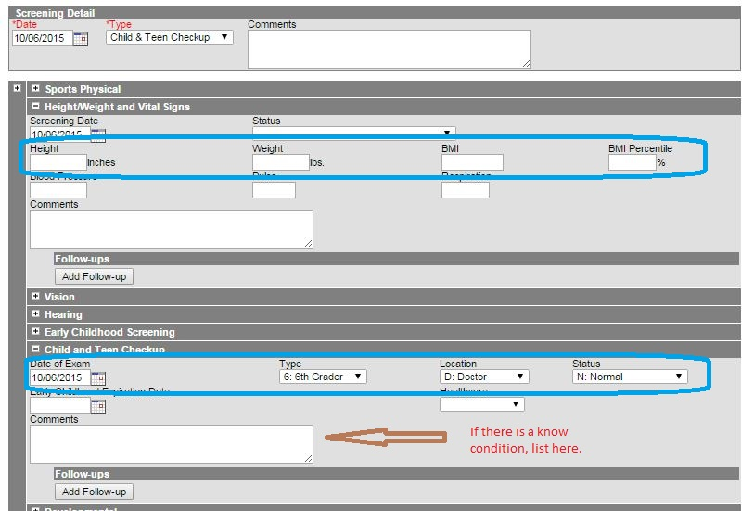

**Grade 00 with no Vision Exam**

Students on this report did not meet the criteria of an exam dated before October 15 and entered into IC. Please check to see if the date is incorrect or if there is evidence that they did have an exam prior to 10/15. KRS 156.160 requires that evidence shall be submitted to the school no later than January 1 of the first year that a three (3), four (4), five (5), or six (6) year-old child is enrolled in a public school, public preschool, or Head Start program.



**Appendix D**

**Uploading Student Health Documents**

This feature may be used to save any health records instead of keeping a paper copy in the Student Cumulative Folder.

Path: *Student Information>Health>Documents*

picture of Campus Community directions on how to upload documents


Source: Infinite Campus, Campus Community, Knowledge Base, Documents (Student Health)